#include <iostream>
using namespace std;
int main() {
int n,m,a[10][10],al[10][10],av[10],f[10]={0},s[10],k=0;
cin>>n>>m;
for(int i=0;i<n;i++)
for(int j=0;j<m;j++) cin>>a[i][j];
for(int i=0;i<n;i++)
for(int j=0;j<m;j++) cin>>al[i][j];
for(int j=0;j<m;j++) cin>>av[j];
int need[10][10],work[10];
for(int i=0;i<n;i++)
for(int j=0;j<m;j++) need[i][j]=a[i][j]-al[i][j];
for(int j=0;j<m;j++) work[j]=av[j];
for(int c=0;c<n;c++)
for(int i=0;i<n;i++) if(!f[i]) {
int j;
for(j=0;j<m;j++) if(need[i][j]>work[j]) break;
if(j==m) {
for(j=0;j<m;j++) work[j]+=al[i][j];
s[k++]=i; f[i]=1;
}
}
if(k==n) {
cout<<"Safe sequence: ";
for(int i=0;i<n;i++) cout<<"P"<<s[i]<<" ";
} else cout<<"Unsafe state";
}

Title:
Write a program in C/C++ to implement the Banker’s Algorithm for Deadlock Avoidance.

Objective
- To understand deadlock avoidance technique.
- To implement Banker’s Algorithm.
- To determine whether the system is in a safe state.
- To find the safe sequence of processes.

Problem Statement
Write a C/C++ program to implement Banker’s Algorithm to determine whether a system is in a safe state or not and to find the safe sequence of processes based on Allocation, Maximum and Available resource matrices.

Software Requirements
Component | Requirement
Operating System | Windows / Linux / Mac
Programming Language | C or C++
Compiler | GCC / Turbo C++ / VS Code
RAM | Minimum 2 GB
Editor | Notepad++ / VS Code / CodeBlocks

Hardware Requirements
Component | Requirement
Processor | Intel i3 or above
RAM | Minimum 2 GB
Hard Disk | Minimum 20 GB free space
Keyboard | Standard Keyboard
Monitor | Any display monitor

Theory
Banker’s Algorithm
Banker’s Algorithm is a deadlock avoidance algorithm used in Operating Systems. It checks whether allocating resources to a process will keep the system in a safe state.
The algorithm works like a banker who gives loans only if he knows he can satisfy all customers safely.

Deadlock
Deadlock is a situation where processes wait indefinitely for resources held by each other.
Example:
Process P1 waits for resource held by P2 and P2 waits for P1.

Safe State
A system is in a safe state if there exists at least one sequence in which all processes can complete execution.
Example Safe Sequence:
P1 → P3 → P4 → P0 → P2

Matrices Used in Banker’s Algorithm
1. Allocation Matrix
Shows resources currently allocated to each process.
Example:
Process | R1 | R2 | R3
P0 | 0 | 1 | 0
P1 | 2 | 0 | 0

2. Maximum Matrix
Shows maximum resources required by each process.
Example:
Process | R1 | R2 | R3
P0 | 7 | 5 | 3
P1 | 3 | 2 | 2

3. Need Matrix
Shows remaining resources required.
Formula:
Need = Max – Allocation
Example:
Process | Max | Allocation | Need
P0 | 7 5 3 | 0 1 0 | 7 4 3

4. Available Matrix
Shows currently available resources.
Example:
3 3 2

Flow Chart
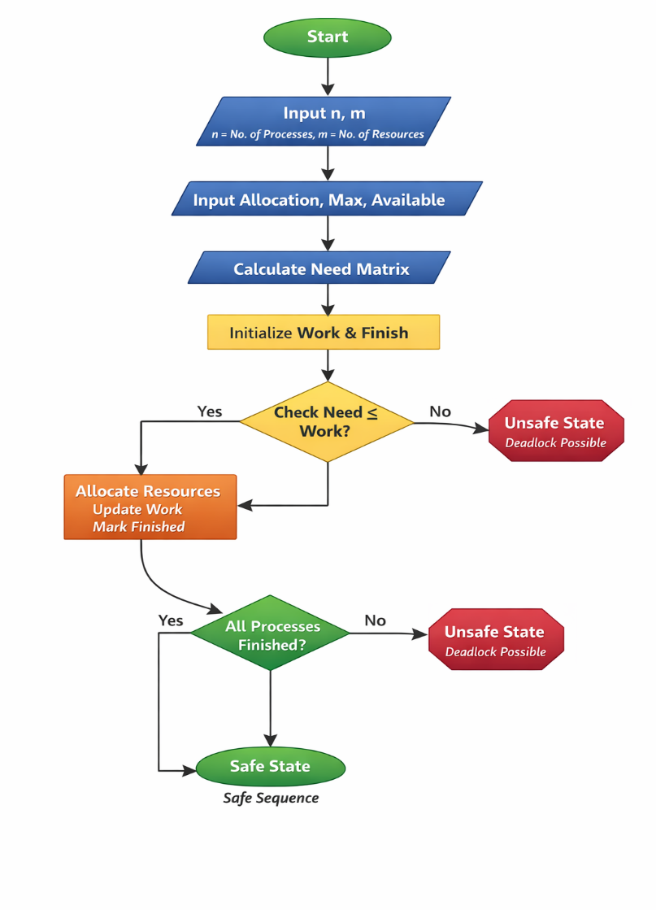

Banker’s Algorithm Steps
- Calculate Need matrix:
Need = Max – Allocation
- Initialize:
Work = Available
Finish[i] = false
- Find process where:
Need ≤ Available
- If found:
- Add allocation to available
Available = Available + Allocation
- Mark process finished.
- Repeat until all processes finish.
- If all processes finish → Safe state.
- If not → Unsafe state.

Advantages
- Avoids deadlock.
- Ensures safe resource allocation.
- Improves system reliability.

Disadvantages
- Requires prior knowledge of maximum resources.
- More computation overhead.
- Not suitable for dynamic systems.

